NSSA-220 Project 1: Application Performance Monitoring

Elvis Lin, Anuj Agrawal, Jeliel Brown

Introduction

This project focused on building an Application Performance Monitoring (APM) tool using a Bash script. The goal was to run multiple applications and continuously monitor their performance by collecting process-level and system-level metrics. These metrics included CPU usage, memory usage, network activity, and disk performance, which were recorded over time in CSV files. The collected data was then analyzed using graphs to better understand system behavior and resource utilization.

Process Level Metrics
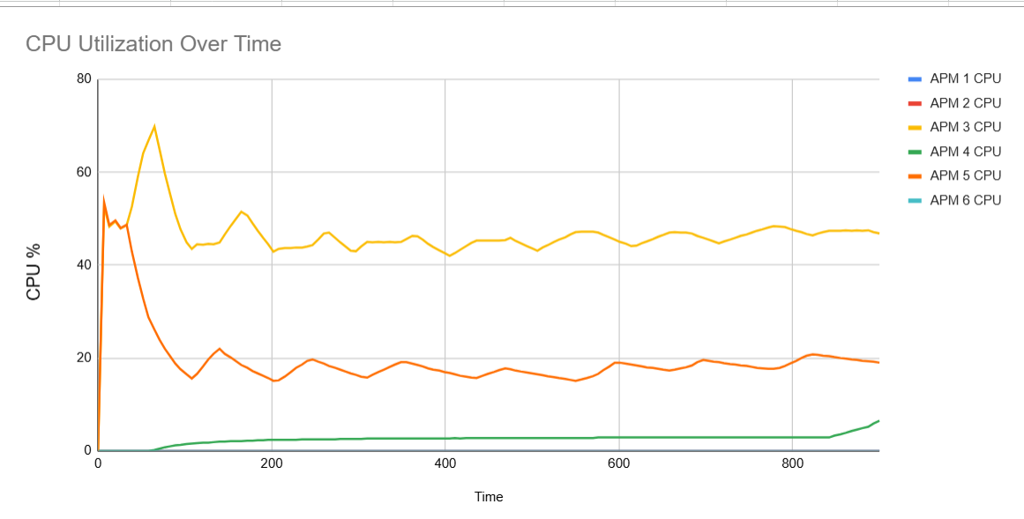

The plot shows CPU utilization for six APMs over time, with APM 3 (yellow) consistently using the most CPU, stabilizing around 40-50%. APM 5 (orange) starts high, then quickly drops and fluctuates in the mid-teens to around 20%, while APM 4 (green) slowly increases from near 0 up to about 6-7%. The other APMs (1, 2, and 6) use almost no CPU throughout the period. The CPU utilization plot shows how much processing power each application used over time. The values fluctuate, indicating periods where the application was more or less active.
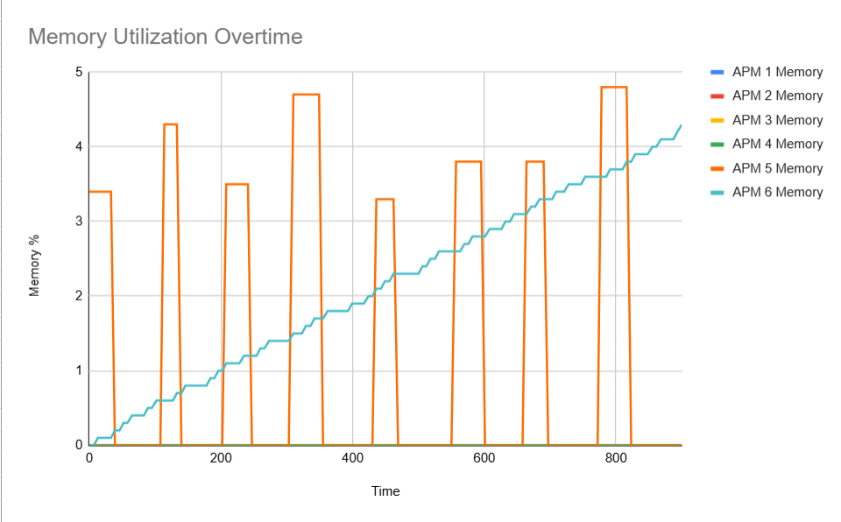

The plot shows memory utilization for six APMs over time, but only APM 5 and APM 6 actually consume noticeable memory. APM 6’s usage (teal line) increases gradually and steadily from near zero to about 4.3 units, while APM 5’s usage (orange spikes) jumps to high levels intermittently and then returns to zero between spikes.
APM 3 used the most sustained CPU, with APM 5 also relatively high but in fluctuating bursts, while APMs 1, 2, and 6 used essentially no CPU, and APM 4 stayed low but gradually increased. For memory, only APM 5 and APM 6 used notable amounts: APM 5 showed sharp, periodic spikes that returned to zero, whereas APM 6 increased steadily over time. That steadily rising APM 6 memory line, without corresponding drops, looks like a potential memory leak.

System Level Metrics
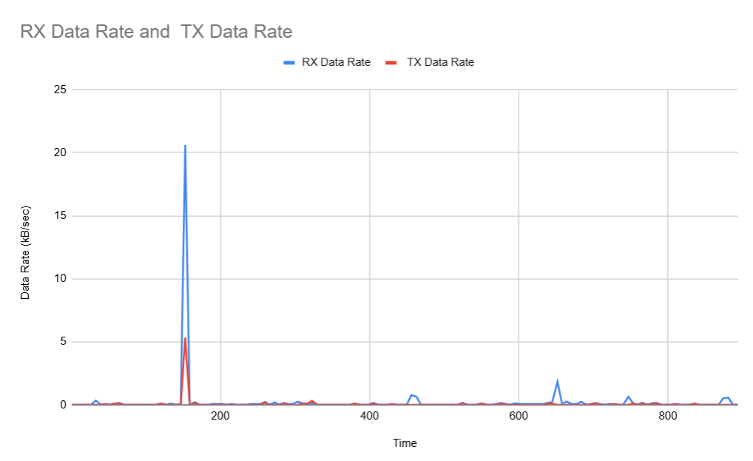
The network bandwidth plot shows that both RX (receive) and TX (transmit) data rates are usually near zero, indicating very low ongoing network usage. There is one major spike early in the period where RX briefly jumps above 20 units and TX rises above 5 units, followed by a few small RX spikes later on while TX stays essentially flat. This suggests occasional short bursts of inbound traffic with minimal sustained or outbound activity

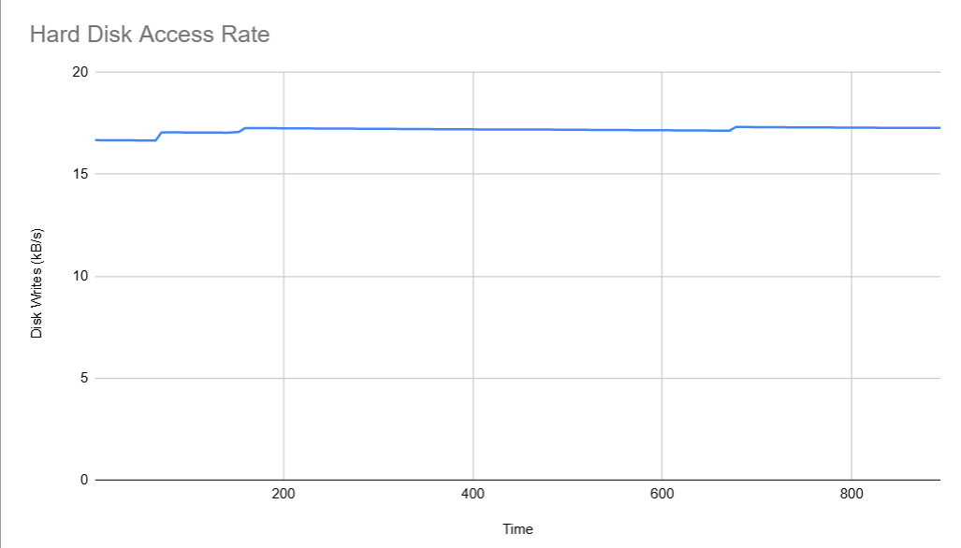

The hard disk access rate stays consistently high and almost flat over time, hovering around 17 units with only very slight variations. Which indicates steady, continuous disk write activity rather than bursts or idle periods.

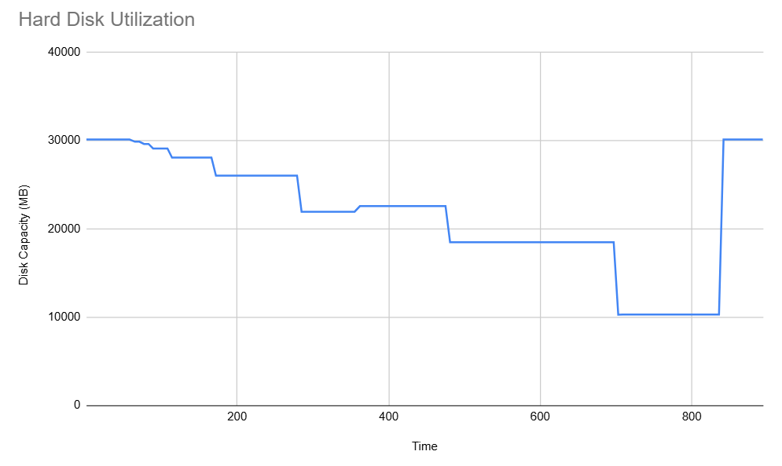

The hard disk utilization plot shows available disk space steadily decreasing in large steps from about 30,000 units down to around 10,000 over time, indicating progressive consumption of storage. Near the end, disk space jumps sharply back up to about 30,000 units, suggesting a cleanup or deletion of large amounts of data

The transmit and receive data rates were generally very similar in shape, with both staying near zero most of the time and only spiking briefly once early in the run (a larger spike on RX, smaller on TX), plus a few small RX-only blips later. Overall, the pattern suggests short, infrequent bursts of network activity rather than steady throughput. The hard disk access rate, by contrast, was almost perfectly flat at a relatively high write rate, indicating continuous background writing. Hard disk utilization showed a staircase-like decline in free space over time, with a sudden jump back up near the end, consistent with data accumulating and then a large cleanup or deletion event.

Summary and Lessons Learned
Overall, the VM appeared to have sufficient computing resources for the workload: CPU usage stayed well below saturation, memory pressure was moderate aside from one process with a possible leak, network traffic was mostly idle with only brief spikes, and disk space, while steadily consumed, never actually ran out before a cleanup. The main concern was the steadily increasing memory usage of one APM, which suggests we’d want better monitoring and limits in a production setting. As a team, we learned the importance of dividing responsibilities clearly (data collection, analysis, visualization), communicating frequently about assumptions, and using shared tools/documentation so everyone interpreted the performance metrics consistently.

